Welcome to our primary school “Lacák”

“Learning is a treasure that will follow its owner everywhere”
Chinese proverb

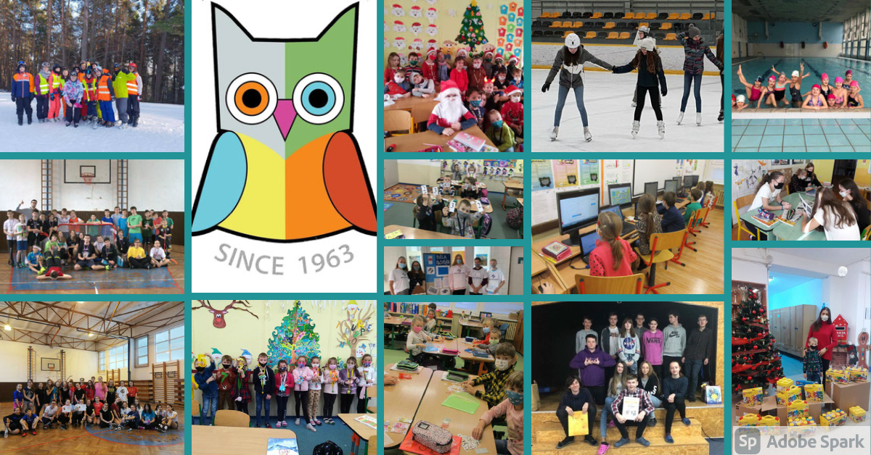

About us
The history of our school goes back to the 1st of September, 1963, when a primary school, at Kovacska 30, experimented with an extended foreign language curriculum. After a big success, the entire school was transformed and started providing extended foreign language teaching throughout.
The school began to teach two compulsory foreign languages, however, from the third grade, pupils could choose between English, German, Russian and French language. Applicants from all over the city were admitted to the third year on the basis of entry exams that tested their proficiency in Slovak language, imitation of a foreign language and listening tasks.
There has always been a great interest in studying at our school. It grew to 22 classrooms with more than 600 pupils but the premises did not meet the conditions of modern language teaching. Hence, the school was relocated to a new modern building at Námestie Ladislava Novomeského 2 on the 1st of September, 1974.
The school has continued to grow in popularity with our core values of integrity, excellence and humanity.
All faculty and students take pride in being a member of our institution. Our school has accomplished a lot during its 50-years of existence. Notably, we are always ranked among the top positions of the best schools in the city thanks to the hard-working, passionate, and goal-oriented faculty members.
We maintain a strong team of teachers who ensure high-quality teaching standards, especially in the Slovak language, mathematics and foreign languages.
We believe that no other school can offer our level of quality education to your children. We aim to create a happy and safe environment that helps children to learn with encouragement.

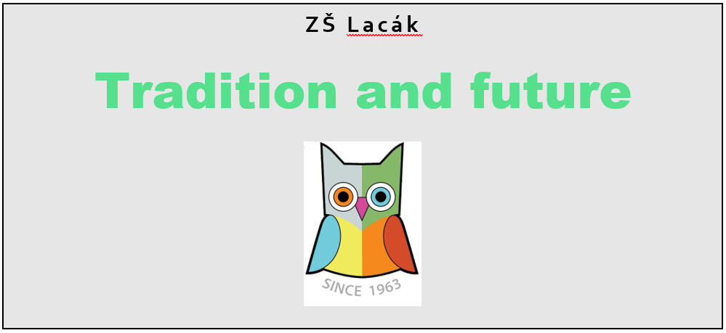

Why ZŠ Lacák?
- High-quality foreign language teaching from year one. The second foreign language is compulsory from the 4th year
- Language courses with a foreign lecturer in the range of 35 hours
- ICT classrooms (2) with 24 PCs and with 14 PCs, along with mobile ICT units (15 netbooks), use of ICT in teaching, working on the internet
- Specialized classroom for social science subjects (20 tablets)
- Possibility of working with an interactive whiteboard (3 classrooms, 23 trained teachers)
- Possibility of working with data projectors
- LEGO classroom for the 1st and 2nd grade
- Student classification information published on online platforms (Edupage, MS Teams)
- School library
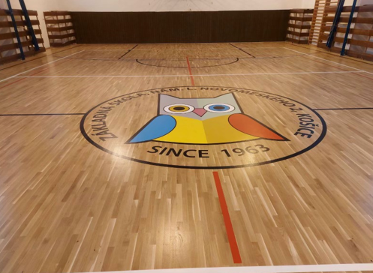
- Regular renovation of the interior of the school (replacement of furniture, repainting of the classrooms and corridors, replacement of lighting fixtures, reconstruction of the second floor, reconstruction of the entrance and cabinets)
- Sports and recreational use of a multi-purpose open sports field and 2 gyms
- Cooperation of school leaders and the student parliament - organization of various activities and competitions
- Extracurricular activities with a focus on preparation for job interviews in profiling subjects, on expanding knowledge of languages ​​and mathematics, and relaxation - touristic activities, a number of sport classes led by professional coaches
- After school club for children / from 6.00 - 17.00, fee: 11.00 € / month /
- School canteen that provides meals for pupils according to their specific meal requirements. We offer meals for children who suffer from diabetes and celiac disease. We would like to help you, dear parents, and make it easier for you to take care of your children's daily nutrition.

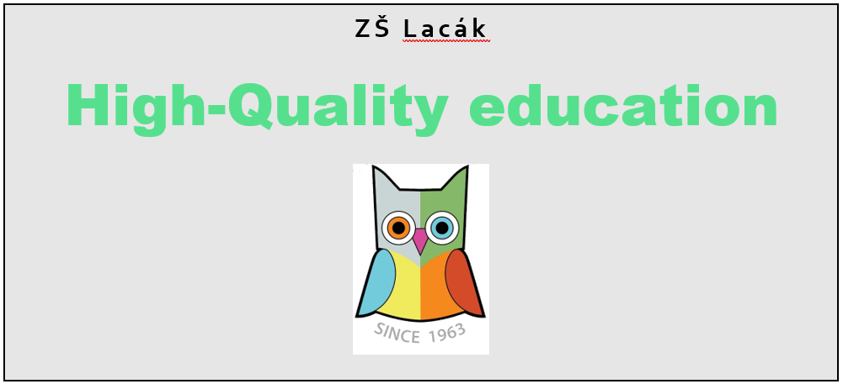

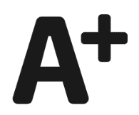
Our best achievements
- Excellent results of the 9th grade students in MONITOR (final exams)
- 100% placement of our students in grammar schools and high schools
- Significant student achievements in the district and in the regional rounds of Olympiads
- Significant student awards for literary work in Slovakia
- Involved in the COMENIUS project - multilateral partnerships where we chose partner countries for cooperation - Spain, Slovenia, Italy, Turkey
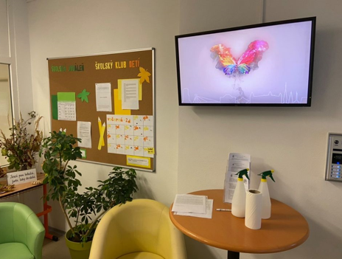
- Long tradition of publishing the NOVO2 magazine
- Presentation of the school to the public in regional media - TV NAŠA and Staromestské listy
- Annual organization of the Christmas and Easter stock exchange event with a presentation of the work of our students associated with the collection of funds used for charitable activities of the school
- Our charitable activities: cooperation with the crisis center (collection of clothes and toys), financial donations for hospitals and the Union of the Visually Impaired and the Blind in Slovakia, food collections and financial donations for shelters.

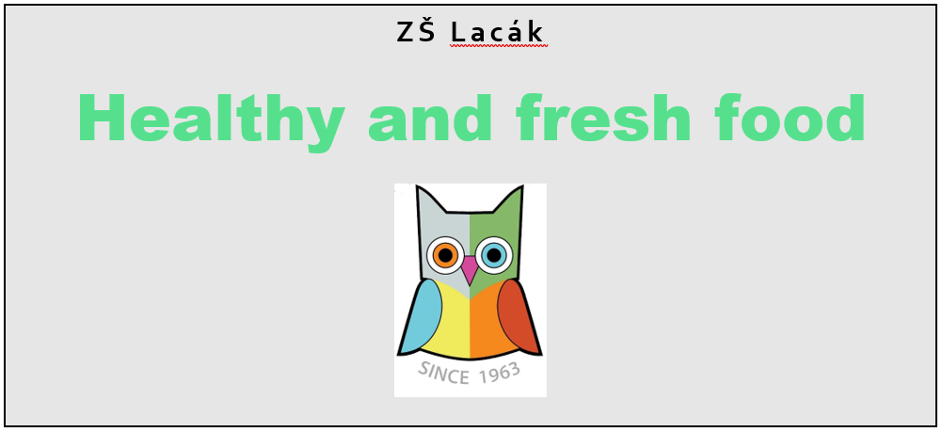

School canteen
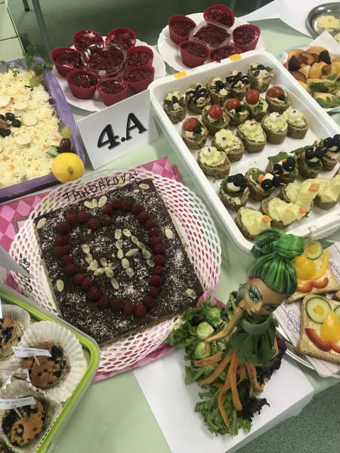
Our school canteen holds a special position to make a positive contribution to our students’ welfare and health. Therefore, we buy our products fresh every day from local suppliers. Our canteen caters healthy, nutritious and delicious food for pupils and employees according to their age-specific and health-specific needs and preferences. We are proud that we can provide meals for pupils with special dietary needs such as children who suffer from diabetes and celiac disease. 165 children can eat in the canteen at the same time. Lastly, we organize various events there too, for example, healthy days when children bring products from home and then they display them to each other.

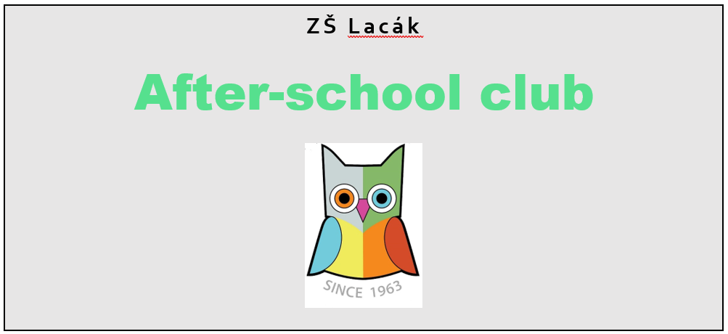

After School Club
Welcome to our After-School Club! For our children (grades 1-4) we provide an after-school club where our main goal is to have fun and relax. In the afternoon, there are several fun ways for the children to play, gain new experiences, learn new skills and to enjoy a relaxing environment.
353 children visited our ŠKD in 2020/2021. We have a timetable which specifies every day of the workweek. From Monday to Friday we have activities throughout the day.
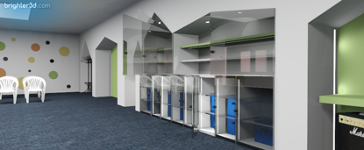
Every day, we work on different thematic areas:
Monday: social sciences education
Tuesday: aesthetic education
Wednesday: science education
Thursday: technical education
Friday: physical education
We can proudly say that our first magazine for kids was published in February 2021.
We kindly invite you to visit our gallery: https://zsnovo.edupage.org/a/galeria-4

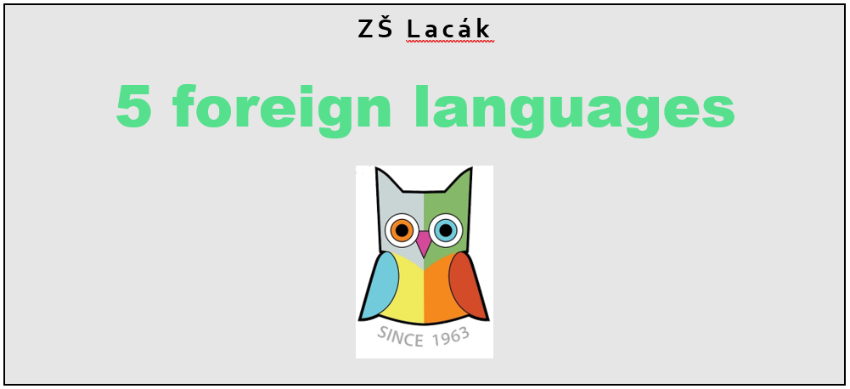

Language School
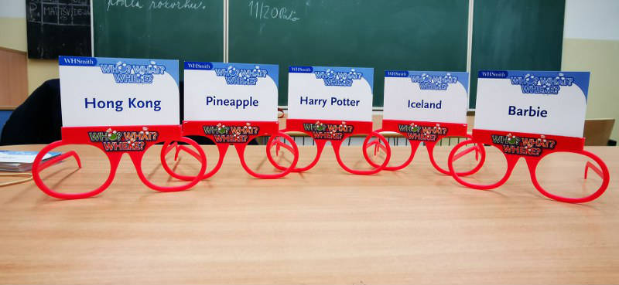
Based on the interest of our pupils and the public, the language school provides the following courses:
• English for adults
• Fairytale English
• Playful English
• Wise headers
• PET 1
• French for beginners
• German with a smile 1 and 2
• Adventure book club
Courses led by native-speakers completed with a Cambridge exam:
• Preparatory course for YLE Starters
• YLE Flyers preparation course
• YLE Movers preparation course
In 2018, we became the first and only primary school in Slovakia that obtained a quality certificate enabling an international level of testing of French language: DELF and DELF junior. The DELF diploma is issued by the French Ministry of Education. It has a lifelong, international validity.

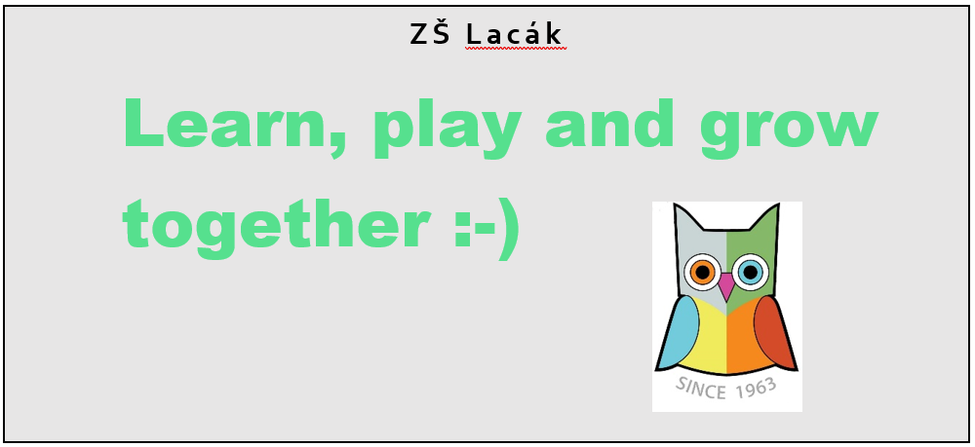

Leisure center
In the afternoon we operate a leisure center for our pupils. Whether you are looking for a leisure dance class, basketball class, athletics, tennis or you just want to improve your skills in art, mathematics or slovak language, there is something for everyone. To find out more, please, visit our website:
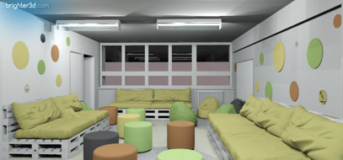
https://zsnovo.edupage.org/a/ponuka-kruzkov.

